- Copy of the launch file from ROS Ag and work to get each element to load without error
- Go back and piece together your startup commands and get each of them working 1-by-1
- One of the differences is the TTGO board is controlling steering and speed. When the switch is set to be in “ROS Mode”, then it will need to listen to cmd_vel

Old fashioned way of starting things:
$ bash ros_start.sh (gui) - step 1
roslaunch teensy_launch.launch
roslaunch nmea_serial_driver.launch
$ python serial_to_ros.py (gui) - step 1 # takes output from IMU nano and publishes it
$ roslaunch tractor_teleop drive.launch (gui) - step 2
$ roslaunch nmea_serial_driver.launch (gui) - step 3

$ roslaunch nmea_serial_driver.launch
/home/ubuntu/catkin_ws/src/nmea_navsat_driver/launch
$ rosrun beginner_tutorials gps_odom.py (gui) - step 4
$ roslaunch lawn_tractor_sim lawn_tractor.launch (gui) - step 5

Previous way of starting things:
roslaunch teensy_launch.launch
# used to set parameters and start rosserial_python to get data from Teensy boards to ROS
publish
# steering angle, speed and control the steering motor and transmission control motor

<rosparam param="steering">[-14000.0, 13500.0, 0.0, 60.0, 3.0]</rosparam>
<rosparam param="speed">[1000.0, 1290.0, 1600.0, 135.0, -100.0, 70.0, 5.0, 0.0, 20.0]</rosparam>
<node ns="transmission_teensy" name="transmission_cntrl" pkg="rosserial_python" type="serial_node.py" args="/dev/transmission_control" output="screen" />
<node ns="left_speed_teensy" name="left_speed" pkg="rosserial_python" type="serial_node.py" args="/dev/odom_left" output="screen" />
<node ns="front_angle_teensy" name="front_angle" pkg="rosserial_python" type="serial_node.py" args="/dev/front_angle" output="screen" />
<node ns="steer_motor_teensy" name="steer_motor" pkg="rosserial_python" type="serial_node.py" args="/dev/steer_motor" output="screen" />

roslaunch nmea_serial_driver.launch
# used to start nmea_navsat_driver

<arg name="port" default="/dev/ttyUSB0" />
<arg name="baud" default="4800" />
<arg name="frame_id" default="gps" />
<arg name="use_GNSS_time" default="False" />
<arg name="time_ref_source" default="gps" />
<arg name="useRMC" default="False" />

<node name="nmea_serial_driver_node" pkg="nmea_navsat_driver" type="nmea_serial_driver" output="screen">
<param name="port" value="$(arg port)"/>
<param name="baud" value="$(arg baud)" />
<param name="frame_id" value="$(arg frame_id)" />
<param name="use_GNSS_time" value="$(arg use_GNSS_time)" />
<param name="time_ref_source" value="$(arg time_ref_source)" />
<param name="useRMC" value="$(arg useRMC)" />
</node>

$ python serial_to_ros.py # takes output from IMU nano and produces ros topics from a serial data stream

$ roslaunch tractor_teleop drive.launch

<launch>
<!-- Joystick Input Node -->
<include file="$(find tractor_teleop)/launch/drive_teleop.launch"/>
<!-- Multiplex Motor Commands Node -->
<include file="$(find tractor_teleop)/launch/cmd_vel_mux.launch"/> {this let the joystick take over if needed}
</launch>

$ rosrun beginner_tutorials gps_odom.py
# Subscribes to heading and fix and then publishes odom, plus broadcasts a transform between odom and base_footprint
self.heading_sub = rospy.Subscriber("heading", QuaternionStamped, self.heading_callback)
self.fix_sub = rospy.Subscriber("fix", NavSatFix, self.gps_callback)
self.odom_pub = rospy.Publisher("odom", Odometry, queue_size=1)
odom_broadcaster.sendTransform((_xg, _yg, 0.0), self.odom_quat, rospy.Time.now(), "base_footprint", "odom")

$ roslaunch lawn_tractor_sim lawn_tractor.launch
# Set the URDF, pkg="robot_state_publisher", node pkg="mbf_costmap_nav", node pkg="lawn_tractor_navigation", pkg="map_server" and fake localizations:
<node pkg="tf" type="static_transform_publisher" name="map_to_odom" args="0.0 0.0 0.0 0 0 0.0 map odom 100"/>
<node pkg="tf" type="static_transform_publisher" name="map_to_utm" args="0.0 0.0 0.0 0 0 0.0 map utm 100"/>

I want a tree similar to below
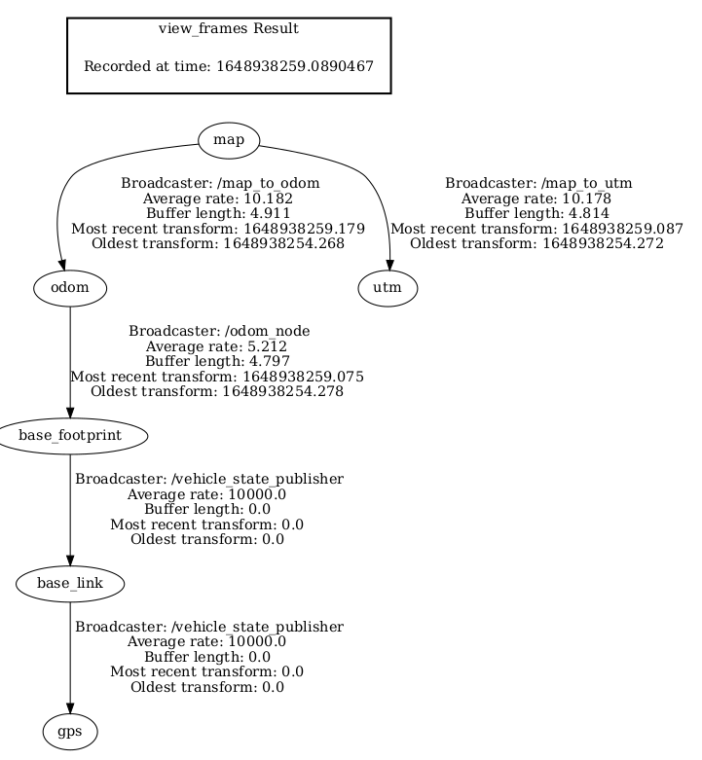

So I’m going to:
- $ roslaunch /home/tractor/catkin_ws/src/nmea_navsat_driver/launch/nmea_serial_driver.launch
- $ cd /home/tractor/catkin_ws/src/beginner_tutorials/scripts

- $ chmod +x gps_odom.py
- $ rosrun beginner_tutorials gps_odom.py
- $ rosrun /home/tractor/catkin_ws/src/beginner_tutorials/scripts/gps_odom.py
- $ roslaunch lawn_tractor_sim lawn_tractor.launch (execute this a piece at a time and work through the issues)

- $ source /home/tractor//catkin/devel/setup.bash

$ python3
>>> help("modules")
$ geonav_transform not listed

This url helped with the gps_odom.py tuple issue
http://www.tcrobots.org/Lawntractor/slack2html/html/lawntractor2020.html

- $ roslaunch chip_imu_driver example.launch port:=/dev/ttyUSB1
- $ roslaunch /home/tractor/catkin_ws/src/nmea_navsat_driver/launch/nmea_serial_driver.launch
- $ rosrun /home/tractor/catkin_ws/src/beginner_tutorials/scripts/gps_odom.py

catkin_make --only-pkg-with-deps chip_imu_driver
catkin_make --only-pkg-with-deps <target_package>

$ roslaunch /home/tractor/catkin_ws/src/nmea_navsat_driver/launch/nmea_to_odom.launch

<?xml version="1.0"?>
<launch>
<node name="my_node" pkg="my_package" type="my_node"/>
</launch>
and

roscore&
rosrun my_package my_node

<?xml version="1.0"?>
<launch>
<node name="gps_odom.py" pkg="beginner_tutorials" type="gps_odom.py"/>
</launch>
and

roscore&
rosrun beginner_tutorials gps_odom.py

11/21/22 – checking the tree
$ rosrun tf2_tools view_frames.py && evince frames.pdf

This is all I have

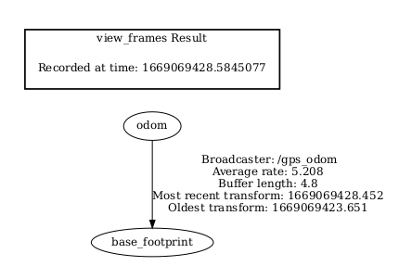

This is in the URDF file
<mesh filename="package://lawn_tractor_sim/meshes/lawn_tractor.dae" scale='1 1 1'/>

So I will download the lawn_tractor.dae file and create the same folder structure then use the URDF and see if it loads

I have put these in a new folder:
- lawn_tractor.dae
- lawn_tractor.urdf.xacro

I have added to
<!-- robot_description is used by nodes that publish to joint_states. -->
<param name="robot_description"
command="$(find xacro)/xacro --inorder $(find lawn_tractor_sim)/urdf/lawn_tractor.urdf.xacro"/>

<!-- Read joint positions from joint_states, then publish the vehicle's
state to tf. -->
<node name="vehicle_state_publisher" pkg="robot_state_publisher"
type="robot_state_publisher">
<param name="publish_frequency" value="30.0"/>
</node>

$ catkin_make –only-pkg-with-deps lawn_tractor_sim # did not work. I used an absolute reference
command="$(find xacro)/xacro --inorder /home/tractor/catkin_ws/src/lawn_tractor_sim/urdf/lawn_tractor.urdf.xacro"/>

11/23/22
Created
roslaunch /home/tractor/catkin_ws/src/lawn_tractor_sim/launch/ros1_navigation.launch
process[move_base_flex-1]: started with pid [5351]
process[map_server-2]: started with pid [5352]
[ INFO] [1669209291.384088863]: Loading map from image "/home/tractor/catkin_ws/src/lawn_tractor_sim/maps/ros_farm_v01.png"
[ERROR] [1669209291.387581313]: failed to open image file "/home/tractor/catkin_ws/src/lawn_tractor_sim/maps/ros_farm_v01.png": Couldn't open /home/tractor/catkin_ws/src/lawn_tractor_sim/maps/ros_farm_v01.png
[map_server-2] process has died [pid 5352, exit code 255, cmd /opt/ros/noetic/lib/map_server/map_server /home/tractor/catkin_ws/src/lawn_tractor_sim/maps/farm.yaml __name:=map_server __log:=/home/tractor/.ros/log/a5131a12-6b2f-11ed-8a15-7950060aa860/map_server-2.log].
log file: /home/tractor/.ros/log/a5131a12-6b2f-11ed-8a15-7950060aa860/map_server-2*.log
[ WARN] [1669209291.857738549]: local_costmap: Pre-Hydro parameter "static_map" unused since "plugins" is provided
[ WARN] [1669209291.860875799]: local_costmap: Pre-Hydro parameter "map_type" unused since "plugins" is provided
[ INFO] [1669209291.862935369]: local_costmap: Using plugin "obstacle_layer"
[ INFO] [1669209291.888826336]: Subscribed to Topics: laser_scan_sensor
[ WARN] [1669209291.996077931]: global_costmap: Pre-Hydro parameter "static_map" unused since "plugins" is provided
[ WARN] [1669209291.997092066]: global_costmap: Pre-Hydro parameter "map_type" unused since "plugins" is provided
[ INFO] [1669209291.998745375]: global_costmap: Using plugin "static_layer"
[ INFO] [1669209292.007711098]: Requesting the map...

RVIS on the Laptop $ rosrun rviz rviz

dae file error
<mesh filename="///home/tractor/catkin_ws/src/lawn_tractor_sim/meshes/lawn_tractor.dae" scale='1 1 1'/>

http://wiki.ros.org/resource_retriever/Tutorials/Retrieving%20Files
resource = r.get("package://resource_retriever/test/test.txt");

11/23/22
tf tree appears to be OK
No major errors when launching files
Yet RVIS, when creating a 2D Nav goal, does not trigger cmd_vel statements

https://github.com/ros-planning/navigation/blob/noetic-devel/move_base/src/move_base.cpp#L96

https://uos.github.io/mbf_docs/tutorials/beginner/overview/

https://uos.github.io/mbf_docs/
http://wiki.ros.org/move_base_flex/Tutorials

git clone https://github.com/uos/mbf_tutorials.git

fails...
catkin_make does
tractor@tractor-HP-ProBook-645-G1:~/catkin_ws$ rosdep install mbf_beginner mbf_advanced
ERROR: the following packages/stacks could not have their rosdep keys resolved
to system dependencies:
mbf_beginner: Cannot locate rosdep definition for [eband_local_planner]
mbf_advanced: Cannot locate rosdep definition for [moveback_recovery]
tractor@tractor-HP-ProBook-645-G1:~/catkin_ws$

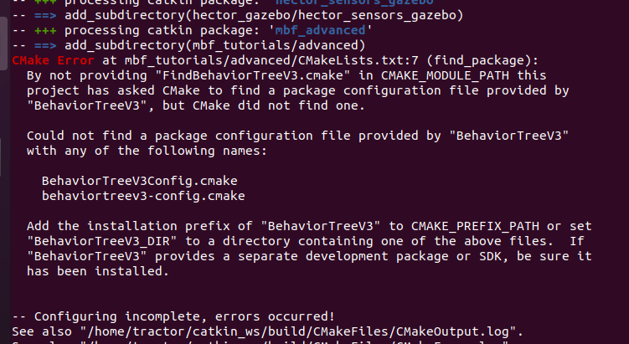

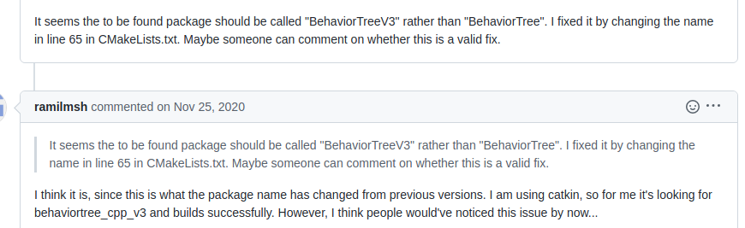

fAILED
sudo apt-get install ros-noetic-eband-local-planner

git clone https://github.com/utexas-bwi/eband_local_planner.git

Trying
http://wiki.ros.org/navigation/Tutorials/SendingSimpleGoals#:~:text=This%20line%20includes%20the%20action%20specification%20for%20move_base,robot%20to%20the%20specified%20position%2Forientation%20in%20the%20world.

sudo apt-get install ros-$ROS_DISTRO-behaviortree-cpp-v3

https://github.com/MortezaAliyari/AGVs-Behavier-Tree-Move_base_flex

11/24/22
Using Gazebo simulator, rqt_graph before starting tebplanner

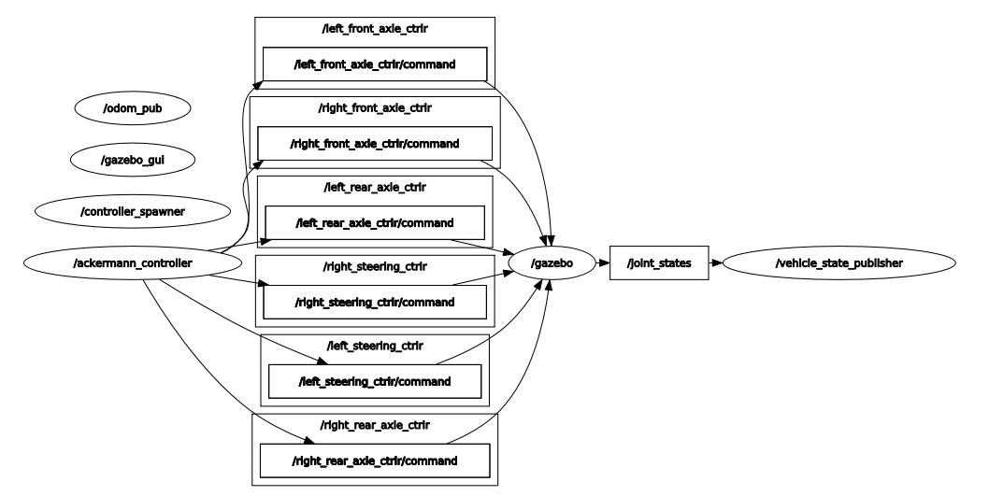

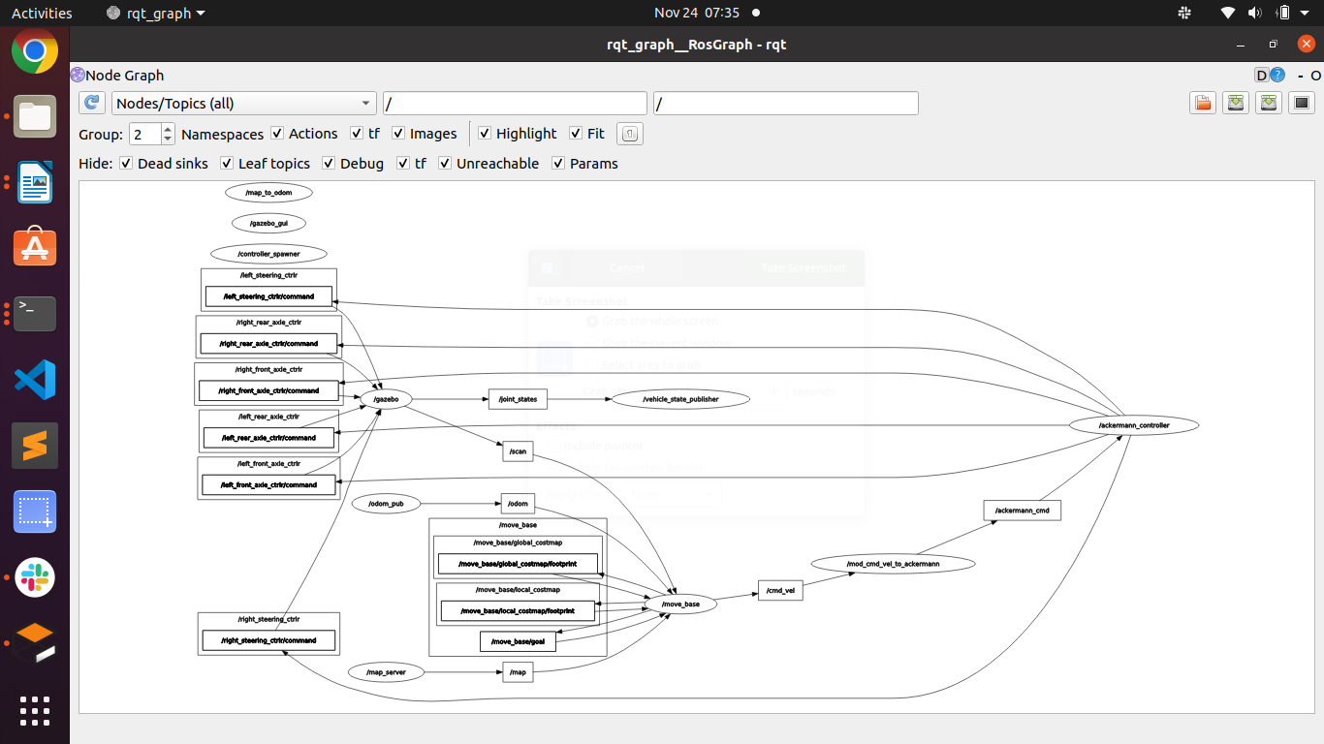

Let’s try $ roslaunch nav nav_newteb.launch using my physical world

To start:
- $ roslaunch /home/tractor/catkin_ws/src/nmea_navsat_driver/launch/nmea_to_odom.launch
- $ roslaunch nav nav_lawn_tractor.launch
- $ rosrun rviz rviz # improve later pointing to config file

Simple goal is publish and subscribed to
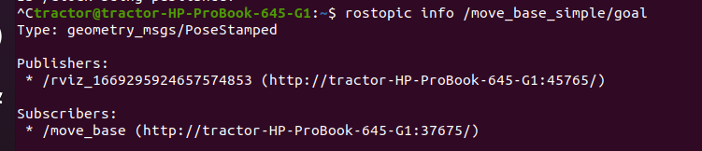

Do I have each of these covered?
- costmap_common_params.yaml
- local_costmap_params.yaml
- global_costmap_params.yaml
- base_local_planner_params.yaml
- global_planner_params.yaml

12/2/22
- - To resolve the issue, “no cmd_vel” from tractor movebaseflex Jeff and I found the code that Vinny apparently used to re-route the movebase/simple_goal to movebaseflex.
- Currently trying to move the needed files from ROSAg to my workspace in order for Vinny’s code to work
- Currently getting the following error:
ERROR: cannot launch node of type [lawn_tractor_navigation/movebaseflex_bt_node]: Cannot locate node of type [movebaseflex_bt_node] in package [lawn_tractor_navigation]. Make sure file exists in package path and permission is set to executable (chmod +x)
- So I need to find “movebaseflex_bt_node” and copy it to lawn_tractor_navigation and rerun catkin_make
- Looks like I need to:
  - check in lawn_tractor_navigation/CmakeLists.txt on my tractor code
  - and
  - ..

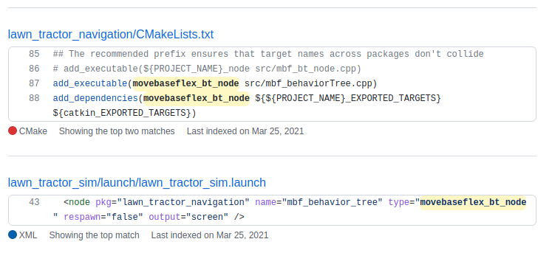

- There are 159 lines in lawn_tractor_navigation/CmakeLists.txt
- There are 205 lines in the tractor version
- Downloading
- $ wget https://raw.githubusercontent.com/username/repository/branch/path/filename.md
- wget https://raw.githubusercontent.com/username/repository/branch/path/filename.md
- lawn_tractor/lawn_tractor_navigation/CmakeLists.txt
- https://github.com/ros-agriculture/lawn_tractor.git

- $ cd /home/tractor/catkin_ws/src/lawn_tractor_navigation
- $ wget https://github.com/ros-agriculture/lawn_tractor/lawn_tractor_navigation/CmakeLists.txt
- https://github.com/ros-agriculture/lawn_tractor
- Did not work. Going to copy raw text
- https://github.com/ros-agriculture/lawn_tractor/tree/master/lawn_tractor_navigation
- https://github.com/ros-agriculture/lawn_tractor/lawn_tractor_navigation
- This didn’t work
  - $ wget https://github.com/ros-agriculture/lawn_tractor/blob/master/lawn_tractor_navigation/CMakeLists.txt

- I ended up opening the file in the browser, RAW, right click, save as

Next issue:
This file is mentioned in the cmake file:
add_executable(movebaseflex_bt_node src/mbf_behaviorTree.cpp)

See if you have downloaded, “movebaseflex_bt_node src/mbf_behaviorTree.cpp”
Yes, it is in lawn_tractor_navigation/src

$ catkin_make failed
-- +++ processing catkin package: 'lawn_tractor_navigation'
-- ==> add_subdirectory(lawn_tractor_navigation)
CMake Error at lawn_tractor_navigation/CMakeLists.txt:9:
Parse error. Expected a command name, got unquoted argument with text
"<!DOCTYPE".

The above was caused by the wget pulling down an html version of the file. I used save as on the raw file.

Next issue
-- +++ processing catkin package: 'lawn_tractor_navigation'
-- ==> add_subdirectory(lawn_tractor_navigation)
-- Using these message generators: gencpp;geneus;genlisp;gennodejs;genpy
CMake Error at /opt/ros/noetic/share/catkin/cmake/catkin_package.cmake:196 (message):
catkin_package() the catkin package 'actionlib' has been find_package()-ed
but is not listed as a build dependency in the package.xml

The file package.xml needs to be downloaded from ROSAg github (or Google Drive backup)

Next issue
-- ==> add_subdirectory(lawn_tractor_navigation)
-- Using these message generators: gencpp;geneus;genlisp;gennodejs;genpy
CMake Error at /opt/ros/noetic/share/catkin/cmake/catkin_package.cmake:305 (message):
catkin_package() include dir 'include' does not exist relative to
'/home/tractor/catkin_ws/src/lawn_tractor_navigation'
Call Stack (most recent call first):
/opt/ros/noetic/share/catkin/cmake/catkin_package.cmake:102 (_catkin_package)
lawn_tractor_navigation/CMakeLists.txt:56 (catkin_package)

Looks like I need to copy down:
https://github.com/ros-agriculture/lawn_tractor/tree/master/lawn_tractor_navigation/include

I downloaded the folder from Gdrive and then moved it into lawn_tractor_navigation

OK, now a clean catkin_make. The summarized actions were:
- Cc
- Make a package “lawn_tractor_navigation ”
  - $ cd ..
  - $ cd src
  - $ catkin_create_pkg lawn_tractor_navigation rospy
- Copy down the src folder
  - Google Drive had these files
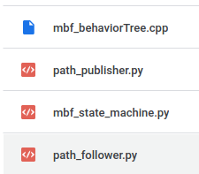

ROSAg had these file:
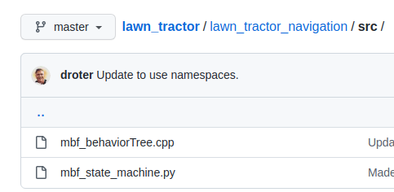

- I used the Google Drive version
- Make .py executable, $ chmod +x mbf_state_machine.py
- copy down the file lawn_tractor/lawn_tractor_navigation/CmakeLists.txt
- copy down the file lawn_tractor/lawn_tractor_navigation/package.xml
- copy down the folder lawn_tractor/lawn_tractor_navigation/include

Next issue, when starting launch files

process[rviz-4]: started with pid [80216]
[ INFO] [1669998510.218648040]: Loading map from image "/home/tractor/catkin_ws/src/lawn_tractor_sim/maps/ros_farm_v01.png"
terminate called after throwing an instance of 'std::runtime_error'
what(): Internal error in realpath(): No such file or directory
[ INFO] [1669998510.443739263]: Read a 1411 X 1168 map @ 0.100 m/cell
[ WARN] [1669998510.663144979]: local_costmap: Pre-Hydro parameter "static_map" unused since "plugins" is provided
[ WARN] [1669998510.670584528]: local_costmap: Pre-Hydro parameter "map_type" unused since "plugins" is provided
[ INFO] [1669998510.683121657]: local_costmap: Using plugin "obstacle_layer"
[ INFO] [1669998510.717084448]: Subscribed to Topics: laser_scan_sensor
[ WARN] [1669998510.987829938]: global_costmap: Pre-Hydro parameter "static_map" unused since "plugins" is provided
[ WARN] [1669998510.989165851]: global_costmap: Pre-Hydro parameter "map_type" unused since "plugins" is provided
[ INFO] [1669998510.992124952]: global_costmap: Using plugin "static_layer"
[mbf_behavior_tree-2] process has died [pid 80213, exit code -6, cmd /home/tractor/catkin_ws/devel/lib/lawn_tractor_navigation/movebaseflex_bt_node __name:=mbf_behavior_tree __log:=/home/tractor/.ros/log/54da8f4a-725e-11ed-951f-ab510d278eeb/mbf_behavior_tree-2.log].
log file: /home/tractor/.ros/log/54da8f4a-725e-11ed-951f-ab510d278eeb/mbf_behavior_tree-2*.log

Let’s look at:
/home/tractor/.ros/log/54da8f4a-725e-11ed-951f-ab510d278eeb/mbf_behavior_tree-2.log

Could not find the log above

I’m seeing this:
xmlrpc.client.Fault: <Fault -1: 'publisherUpdate: unknown method name'>

In: master.log

Error repeated
[roslaunch][ERROR] 2022-12-02 11:28:31,000: [mbf_behavior_tree-2] process has died [pid 80213, exit code -6, cmd /home/tractor/catkin_ws/devel/lib/lawn_tractor_navigation/movebaseflex_bt_node __name:=mbf_behavior_tree __log:=/home/tractor/.ros/log/54da8f4a-725e-11ed-951f-ab510d278eeb/mbf_behavior_tree-2.log].

Running again, error:
[ INFO] [1669999491.588389439]: Loading map from image "/home/tractor/catkin_ws/src/lawn_tractor_sim/maps/ros_farm_v01.png"
terminate called after throwing an instance of 'std::runtime_error'
what(): Internal error in realpath(): No such file or directory
[ INFO] [1669999491.806143446]: Read a 1411 X 1168 map @ 0.100 m/cell
[ WARN] [1669999492.060120843]: local_costmap: Pre-Hydro parameter "static_map" unused since "plugins" is provided
[ WARN] [1669999492.065768136]: local_costmap: Pre-Hydro parameter "map_type" unused since "plugins" is provided
[ INFO] [1669999492.069910577]: local_costmap: Using plugin "obstacle_layer"
[ INFO] [1669999492.111798581]: Subscribed to Topics: laser_scan_sensor
[mbf_behavior_tree-2] process has died [pid 80859, exit code -6, cmd /home/tractor/catkin_ws/devel/lib/lawn_tractor_navigation/movebaseflex_bt_node __name:=mbf_behavior_tree __log:=/home/tractor/.ros/log/9d31d760-7260-11ed-951f-ab510d278eeb/mbf_behavior_tree-2.log].
log file: /home/tractor/.ros/log/9d31d760-7260-11ed-951f-ab510d278eeb/mbf_behavior_tree-2*.log

In Ros Ag there is this...

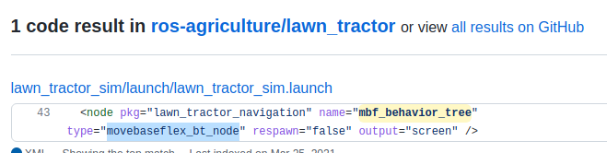

And.....

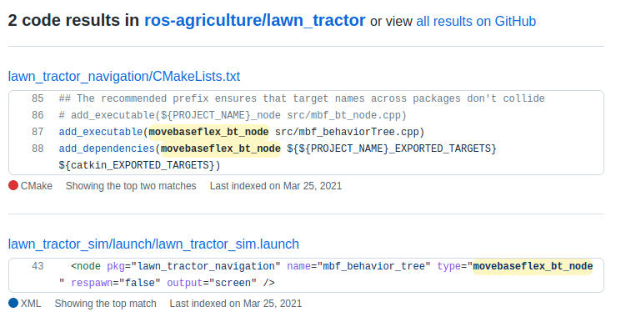

I can start the python program

ref: https://github.com/ros-agriculture/lawn_tractor/blob/aa6af318afc61a08e46c447ee58b689cdaa052dc/lawn_tractor_navigation/src/mbf_state_machine.py

Some documentation to review...
- https://www.behaviortree.dev/docs/Intro
- https://uos.github.io/mbf_docs/tutorials/advanced/pytrees/
- https://github.com/uos/mbf_docs/blob/master/docs/tutorials/advanced/behavior_tree.md

ROS2 tutorial: https://py-trees-ros-tutorials.readthedocs.io/en/devel/tutorials.html

12/3/22 – pull out the behaviour tree and put it in its own launch file. The goal is to add debug statements to see where it is failing.

Failing
process[mbf_behavior_tree-1]: started with pid [12862]
terminate called after throwing an instance of 'std::runtime_error'
what(): Internal error in realpath(): No such file or directory
[mbf_behavior_tree-1] process has died [pid 12862, exit code -6, cmd /home/tractor/catkin_ws/devel/lib/lawn_tractor_navigation/movebaseflex_bt_node __name:=mbf_behavior_tree __log:=/home/tractor/.ros/log/cdda5ec2-7329-11ed-89f9-492abb57fe04/mbf_behavior_tree-1.log].
log file: /home/tractor/.ros/log/cdda5ec2-7329-11ed-89f9-492abb57fe04/mbf_behavior_tree-1*.log

The log file referenced is not in the folder mentioned

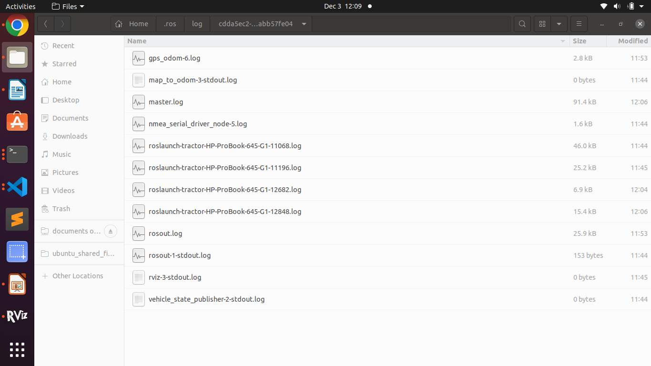

xx
Using this as an example
<node pkg="mbf_costmap_nav" type="mbf_costmap_nav"

Find mbf_costmap_nav
tractor@tractor-HP-ProBook-645-G1:~$ rospack find mbf_costmap_nav
/opt/ros/noetic/share/mbf_costmap_nav

tractor@tractor-HP-ProBook-645-G1:~$ cd /opt/ros/noetic/share/mbf_costmap_nav
tractor@tractor-HP-ProBook-645-G1:/opt/ros/noetic/share/mbf_costmap_nav$ ls
cmake package.xml
tractor@tractor-HP-ProBook-645-G1:/opt/ros/noetic/share/mbf_costmap_nav$ cd cmake/
tractor@tractor-HP-ProBook-645-G1:/opt/ros/noetic/share/mbf_costmap_nav/cmake$ ls
mbf_costmap_navConfig.cmake mbf_costmap_navConfig-version.cmake

I’m wondering if
<node pkg="lawn_tractor_navigation" name="mbf_behavior_tree" type="movebaseflex_bt_node"

movebaseflex_bt_node exists and so I’m wondering where it should be located

<!-- Launch the Chip Robotics IMU driver. -->
<node pkg="chip_imu_driver" type="chip_imu_driver_node" name="chip_imu_driver_node"

tractor@tractor-HP-ProBook-645-G1:~$ rospack find chip_imu_driver
/home/tractor/catkin_ws/src/chip_imu_driver
tractor@tractor-HP-ProBook-645-G1:~$ cd /home/tractor/catkin_ws/src/chip_imu_driver
tractor@tractor-HP-ProBook-645-G1:~/catkin_ws/src/chip_imu_driver$ ls
CMakeLists.txt include launch LICENSE package.xml README.md src
tractor@tractor-HP-ProBook-645-G1:~/catkin_ws/src/chip_imu_driver$ cd src/
tractor@tractor-HP-ProBook-645-G1:~/catkin_ws/src/chip_imu_driver/src$ ls
chip_imu_driver_node.cpp imu_serial.cpp
tractor@tractor-HP-ProBook-645-G1:~/catkin_ws/src/chip_imu_driver/src$

There does not appear to be any copy of movebaseflex_bt_node anywhere.

I’m wondering what “add executable” is doing

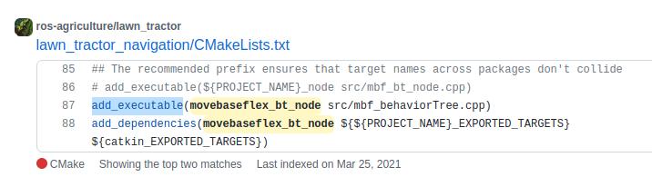

Reviewing https://matgomes.com/cmake-add-executable/

Suggestion, add the full pwd for mbf_behaviorTree.cpp
/home/tractor/catkin_ws/src/lawn_tr

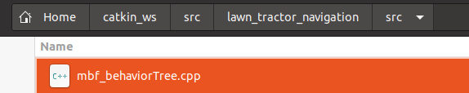

/home/tractor/catkin_ws/src/lawn_tractor_navigation/src
xx

Updated CmakeLists.txt in lawn_tractor_navigation
add_executable(movebaseflex_bt_node /home/tractor/catkin_ws/src/lawn_tractor_navigation/src/mbf_behaviorTree.cpp)

Did not work
ROS_MASTER_URI=http://localhost:11311

process[mbf_behavior_tree-1]: started with pid [17194]
terminate called after throwing an instance of 'std::runtime_error'
what(): Internal error in realpath(): No such file or directory
[mbf_behavior_tree-1] process has died [pid 17194, exit code -6, cmd /home/tractor/catkin_ws/devel/lib/lawn_tractor_navigation/movebaseflex_bt_node __name:=mbf_behavior_tree __log:=/home/tractor/.ros/log/f6cdc0dc-7336-11ed-89f9-492abb57fe04/mbf_behavior_tree-1.log].
log file: /home/tractor/.ros/log/f6cdc0dc-7336-11ed-89f9-492abb57fe04/mbf_behavior_tree-1*.log
all processes on machine have died, roslaunch will exit
shutting down processing monitor...
... shutting down processing monitor complete
done

Looking at this
https://github.com/tum-vision/lsd_slam/issues/321

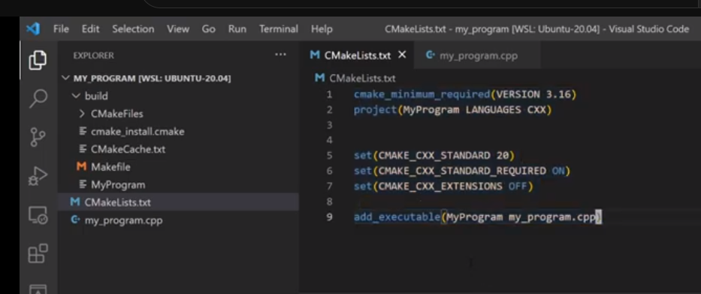

Note that MyProgram, after CMake runs, puts the executable in the build folder of the structure. This means Cmake has to run to prepare movebaseflex_bt_node

So, location of the source file is:
/home/tractor/catkin_ws/src/lawn_tractor_navigation/src/mbf_behaviorTree.cpp

Q: Is there a build folder in lawn_tractor_navigation?
A: No
Q: Is there a build folder in the ROSAg github?
A: No

Seems to me to create movebaseflex_bt_node we have to:

- $ cd /home/tractor/catkin_ws/src/lawn_tractor_navigation
- code .
- Confirm CmakeLists.txt is present and the statement below is present
  - add_executable(movebaseflex_bt_node src/mbf_behaviorTree.cpp)
- Confirm mbf_behaviorTree.cpp is present
- In VS Code, Select Terminal, New Terminal
- $ mkdir build
- $ cd build/
- $ cmake ..
- $ cmake --build .

Then

But I still have a problem. Seems the program is not in the right place.

[mbf_behavior_tree-1] process has died [pid 30317, exit code -6, cmd /home/tractor/catkin_ws/devel/lib/lawn_tractor_navigation/movebaseflex_bt_node __name:=mbf_behavior_tree __log:=/home/tractor/.ros/log/5a8aa39e-7358-11ed-89f9-492abb57fe04/mbf_behavior_tree-1.log].
log file: /home/tractor/.ros/log/5a8aa39e-7358-11ed-89f9-492abb57fe04/mbf_behavior_tree-1*.log

It is actually here:
/home/tractor/catkin_ws/src/lawn_tractor_navigation/build/devel/lib/lawn_tractor_navigation/movebaseflex_bt_node

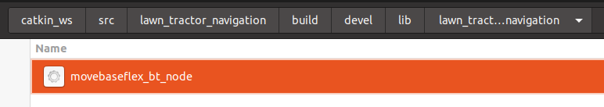

Where does it need to be?

NODES
/
mbf_behavior_tree (lawn_tractor_navigation/movebaseflex_bt_node)

ROS_MASTER_URI=http://localhost:11311

process[mbf_behavior_tree-1]: started with pid [33574]
terminate called after throwing an instance of 'std::runtime_error'
what(): Internal error in realpath(): No such file or directory
[mbf_behavior_tree-1] process has died [pid 33574, exit code -6, cmd /home/tractor/catkin_ws/devel/lib/lawn_tractor_navigation/movebaseflex_bt_node __name:=mbf_behavior_tree __log:=/home/tractor/.ros/log/599b090a-7372-11ed-89f9-492abb57fe04/mbf_behavior_tree-1.log].
log file: /home/tractor/.ros/log/599b090a-7372-11ed-89f9-492abb57fe04/mbf_behavior_tree-1*.log
all processes on machine have died, roslaunch will exit
shutting down processing monitor...
... shutting down processing monitor complete
done
tractor@tractor-HP-ProBook-645-G1:~$

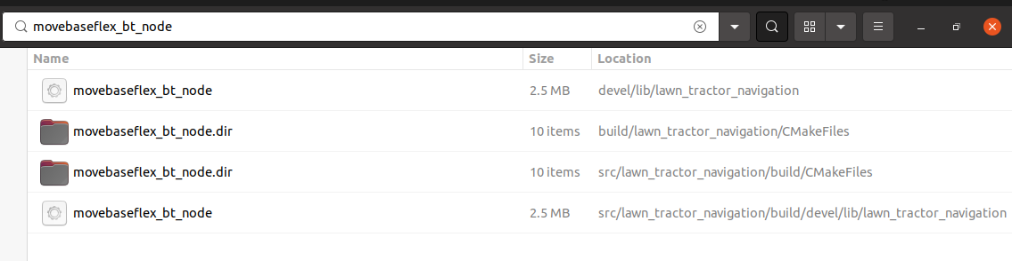
b
Well, I would do the obvious...
Delete the build directory that you created. Then delete:
catkin_ws/devel
catkin_ws/build
Then switch to catkin_ws and do a catkin_make
See what that gives you.

warning: ‘NPY_CHAR’ is deprecated: Use NPY_STRING [-Wdeprecated-declarations]

12/5/22
Looking at the .cpp code it loads movebaseflex_tree.xml

The actual location is:
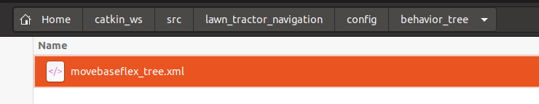

/home/tractor/catkin_ws/src/lawn_tractor_navigation/config/behavior_tree/movebaseflex_tree.xml

In the Google backup movebaseflex_tree.xml is located at:
catkin_ws/src/lawn_tractor/lawn_tractor_navigation/config/behavior_tree/

based on ROS_INFO statement .cpp is looking in:
/home/tractor/catkin_ws/src/lawn_tractor_navigation/config/behavior_tree/movebaseflex_tree.xml

So now it seems to work
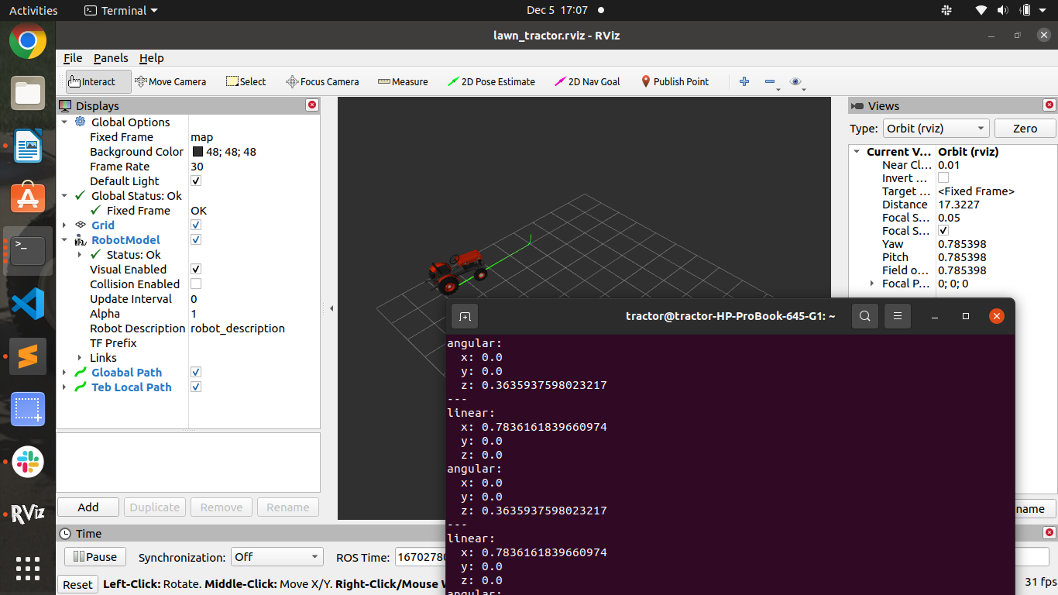

12/7/22 – I was researching building my own map and realized ros_farm_v01.png is not being loaded in rivz

<!-- ****** map server ***** -->
<node name="map_server" pkg="map_server" type="map_server"
args="/home/tractor/catkin_ws/src/lawn_tractor_sim/maps/farm.yaml" output="screen">
<param name="frame_id" value="map"/>
</node>

Rename existing lawn_tractor_sim
Create a lawn_tractor_sim package
    - $ cd catkin_ws/src
    - $ catkin_create_pkg lawn_tractor_sim rospy
    - $ cd ~/catkin_ws
    - $ catkin_make

Move components from “old” folder to newly created package.
Update the launch file to search for the package instead of hard coding

I moved some things around trying to clean up the bringup process. Unfortunately I’m getting this now:
[ INFO] [1670453644.281430374]: Read a 1411 X 1168 map @ 0.100 m/cell
[ WARN] [1670453649.406357133]: Timed out waiting for transform from base_link to map to become available before running costmap, tf error: Could not find a connection between 'map' and 'base_link' because they are not part of the same tree.Tf has two or more unconnected trees.. canTransform returned after 0.100171 timeout was 0.1.

One post says, “This error comes up when the navigation stack could not find a map. Please check your map_name.yaml is looking at the right map_name.pgm file (correct .pgm file path in the .yaml file).”

I’m looking for $(find lawn_tractor_sim)/maps/farm.yaml

It is looking for ros_farm_v01.png which appears in the same folder
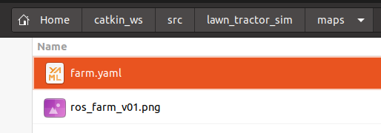

rosrun tf2_tools view_frames.py && evince frames.pdf
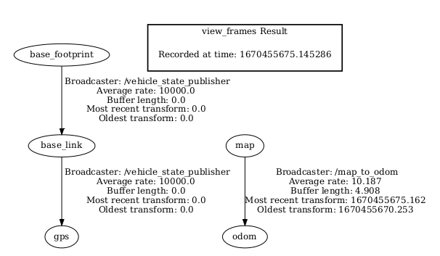

base_footprint is new; I’m not sure where that came from.

12/14/22
I’m trying to get the tractor to drive around the yard.
The TTGO code appears to not have fixed PID settings instead it is programmed to read potentiometer settings on pin 39 and 37
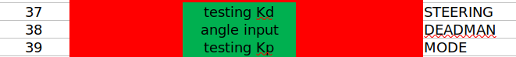

ttgo_board/radio_control_tractor_v1/src/main.cpp

This runs on the TTGO and drives the Steering Motor controller, et. al.
Q: Do I have the latest copy?
- There is a version on GitHub and locally stored

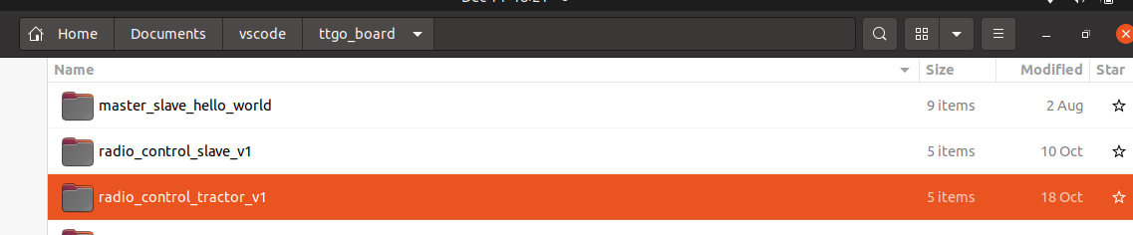

$ cd /home/tractor/Documents/vscode/ttgo_board
$ code .
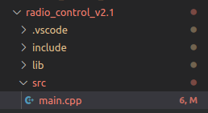

This runs the radio control device

Rename these files and put them in the embedded folder:
- from: radio_control_tractor_v1, to: tractor_control
- from: radio_control_v2.1 to: radio_control

Check the OLED on the tractor and see if it is displaying Kp and Kd. It is not. That is because its coded as a serial print.

Use the serial monitor in VSCode
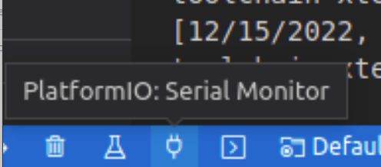

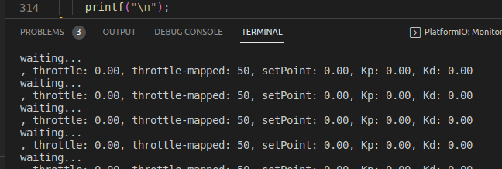

So we are getting output; Now change the pot settings and see if they update.

